**Client-Side App Rubric** <https://github.com/denisecase/pbl-lifeline-links>

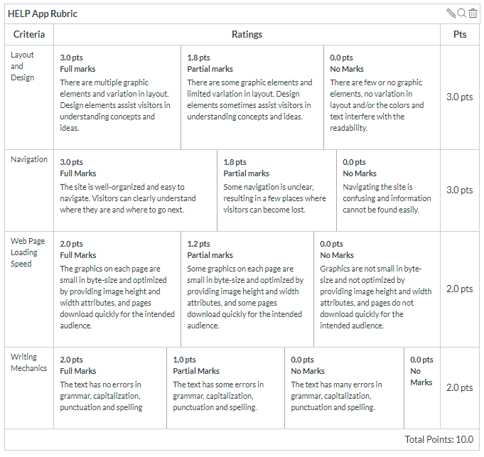

**Team reviewed:** Group 04-03

**Link to the web site:** https://prasu93.github.io/help-app/

**Layout and Design**

Score: 0

Comments: N/A

**Navigation**

Score: 0

Comments: N/A

**Loading Speed:**

Score: 0

Comments: N/A

**Writing Mechanics:**

Score: 0

Comments: N/A

**General remarks:** Site is incomplete or not published. All that can be accessed is a header saying ‘help-app’ and a line underneath that. The rest is empty space.

**Review performed by:** Group 5

**Date and time performed:** 12/3/2019 1:03 pm